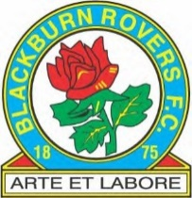

Club Info for Travelling Fans
The address is:
Blackburn Rovers Football Club
Ewood Park
Blackburn
BB2 4JF
Telephone: 01254 372001
Follow the link below for all travel information on how to get to Ewood Park
https://www.rovers.co.uk/club/ewood-park
Car Parking
All Official Car Parks are contactless payment and are £10 on a first come first served basis.
For Disabled Parking please ring Farrah on 01254 508283 during Office hours.
Links to Social Media Accounts
https://www.facebook.com/1Rovers
https://www.instagram.com/rovers/

https://www.twitter.com/rovers
Useful Numbers
Brownhill Taxis 01254 777666
Blackburn Bus Station 01254 585585 email: transdevbus.co.uk/blackburn
Blackburn Railway Station 0800 200 6060

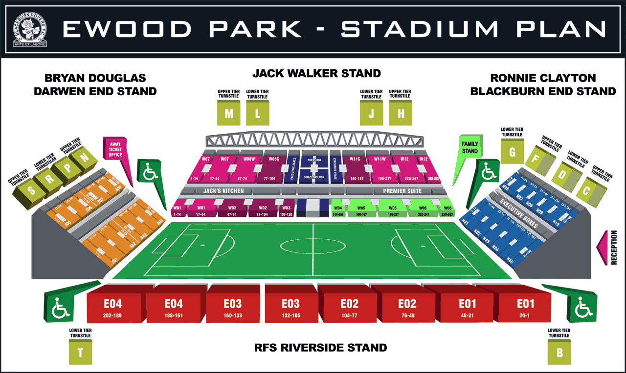Visitors Tickets are situated at the Bryan Douglas Darwen End Stand

