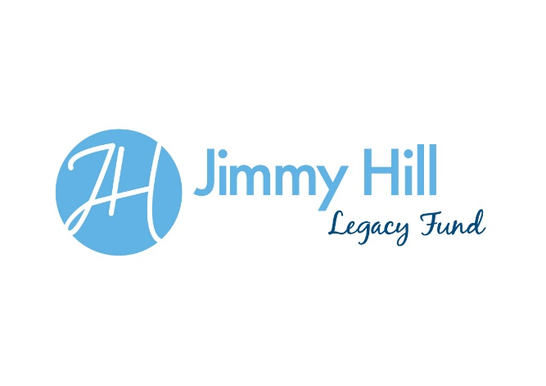
Grant Application Form 2017/18

- Your Charity/Project and your details:

Charity/Project Name:

Charity Number (If applicable):

Address:

Postcode:

E-mail address:

Applicant name:
Applicant role:

Applicant contact number:

- What geographical area will the project which you are applying to be funded cover?

- What is the age range of people who will be impacted by your charity/project?

- What amount of funding are you applying for? The maximum donation amount is £1000.

- Why is this support needed?

- Please explain - Description of the project/activity which the funding is for, What will be money be used to fund, What difference will the grant make to those involved?

- What are the aims and expected outcomes of your project? Please ensure these are SMART – Specific, Measurable, Attainable, Relevant and Timely.

- How many years has your charity/project been in existence?

Please note – we will not fund:
- Profit making organisations
- Organisational overheads (e.g. rent, rates, utilities etc.)
- Pitch fees of training facility hire
- One off trips
Applicant Organisations or individuals will require:
- a bank account
- Minimum of two signatories (where applicable not for individual applicants)
- Child protection and welfare policy, Equal opportunities policy(own governance as required but not for individual applicants)

Evidence Required – the following will need to be provided to the Jimmy Hill Legacy Fund committee:
- End of project report required
- Receipts and evidence of expenditure
- Photos of the work which is being funded
- Midway report
- Evidence of the impact of the funding

NB. During the process of application applicants may be required to discuss their proposal with committee members of the JHLF

