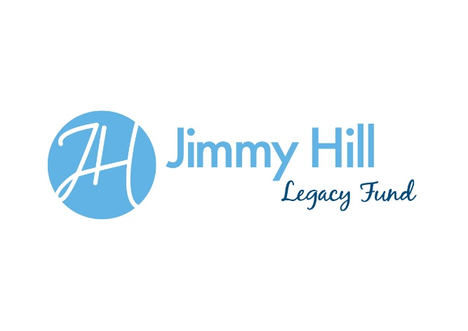
Grant Criteria

- Geographical Area

- Coventry and Warwickshire

- Outcomes:
- Increase opportunities to take part in Sport,Health and Physical activity
- Improve community relations
- Reduce crime and antisocial behaviour
- Improve educational attainment
- Maximum Grant amount (First year)

- Maximum £1000
- Age Range
- Available for people of all ages

- What to Fund
- Any community activity (e.g. Sports, art projects, music, dance, community days)
- What we won’t fund
- Profit making organisations
- Organisational overheads (e.g. rent, rates, utilities etc.)
- Pitch fees of training facility hire
- One off trips
- Applicant Organisations or individuals
- a bank account
- Minimum of two signatories(where applicable not for individual applicants)
- Child protection and welfare policy, Equal opportunities policy(own governance as required but not for individual applicants)

- Application form(1st year build criteria into year 2)

- Name of the organisation and lead person contact details
- Amount requested
- Description of the project, activity or request for support
- Why is this support needed? Who will benefit?
- What difference will the grant make to those involved?
- How will they measure this?(Evidence of need)

- Evidence Required(case studies/media stories for promotion)
- End of project report required – could link this to an instalment payment profile i.e. last instalment paid once end of project evaluation form has been received
- Receipts and evidence of expenditure?
- Request photos of the work which can be used in subsequent case studies and media articles.
- Midway report
- Evidence
JHLF Commitee

