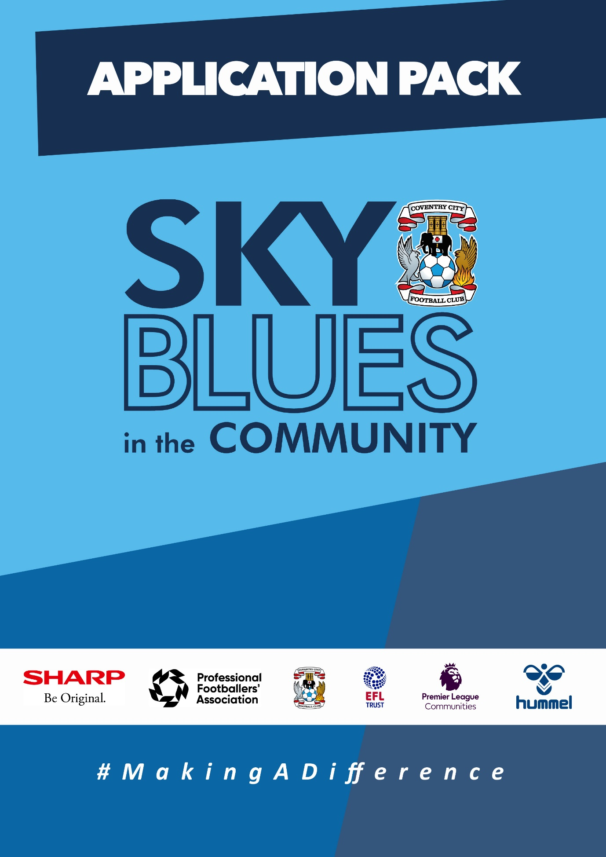

APPLICATION PACK

ABOUT US
Sky Blues in the Community (SBitC) is the official charity arm of Coventry City Football Club, based at the Coventry Building Society Arena. We are committed to harnessing the power of sport and physical activity and utilising Coventry City Football Club’s unique influence and appeal to develop and deliver high quality community programmes and form strategic alliances that empower the people of Coventry and Warwickshire. We provide meaningful opportunities for improved health and wellbeing, enhanced social inclusion, reduced crime involvement, and expanded access to education and training, we will #MakeADifference in our city and county.
The work of Sky Blues in the community is currently categorised under three core themes, each with their own headline goal.
Health and Wellbeing – We will play our part, standing shoulder to shoulder with a host of partners, in combatting the social challenges that currently risk the health and wellbeing of Coventry and Warwickshire’s most underrepresented communities. We will strive to deliver top quality, engaging and impactful community-based programmes that support members of Coventry and Warwickshire to pursue a happier and healthier life.
Education, Skills and Training – We will be integral in improving the training and employment opportunities available in Coventry and Warwickshire by inspiring our people, helping to provide the tools, experiences and guidance needed to build and sustain a prosperous career.
Inclusion, Engagement and Participation – We will create a more active and cohesive Coventry and Warwickshire, giving those that call it home the opportunity to participate in physical activity, enabling everyone to access the benefits of regular exercise barrier-free in an unjudged, welcomed and inspiring way.
People and Infrastructure – We simply could not achieve the impact we do without the dedication and expertise of our people, working tirelessly to ensure the hard-to-reach are reachable. In expanding our scope and deepening our offer, we also need to invest in our people, our foundation and infrastructure. We will ensure that our infrastructure and resources match our ambition, and our staff are representative of our community, ensuring they have access to high quality learning and development opportunities, enabling them to learn new skills and realise their own potential.

The values that we expect our staff to demonstrate at all times are as follows.
- Community Focused
- Passionate
- Innovative
- Ambitious
- Inclusive
Sky Blues in the Community are committed to embracing and fostering equality, diversity and inclusion in the workplace as well as in the delivery of its services, activities, and programmes, by promoting a positive organisational culture that values all staff and service users. We will strive to create an inclusive environment where everyone feels able to participate and achieve their potential.
Sky Blues in the Community operates a person-centred approach to safeguarding and where concerns about the welfare of a child or adult at risk exists, staff will always act with their best interests in mind. Sky Blues in the Community fully acknowledges and accepts its responsibility for the well-being and safety of all children and adults at risk engaged in Trust activities. It is the duty of all staff working at the Trust to ensure they safeguard children and adults at risk by creating an environment that protects them from harm. Safeguarding is everyone’s responsibility.

JOB DESCRIPTION
Job Title: | School Sport and Participation Manager | Reporting to: | Business Development Manager
Salary: | £29,000 per annum | Contract Type: | Full time – 37.5 hours per week
Location: | Coventry Building Society Arena, Judds Lane, Coventry, CV6 6GE | Days and hours of work: | Hours to be confirmed at interview and with job offer.
Document created: | January 2024 | Reference number: | SBITC-SSPM

Purpose of the role:

To lead on Sky Blues in the Community’s school sport offer (PPA/After School Clubs/Joy of Moving and Premier League Primary Stars programme) and recreational holiday camps and Saturday recreational football sessions for children and young people. To be responsible for achieving financial targets set by the senior management team and KPI’s set by funders. To develop and maintain outstanding relationships with local schools and local partners and stakeholders. To continuously improve school sport and participation programmes. To manage and develop a team of School Sport delivery staff and manage their specific professional development and training. To be responsible for quality assurance, monitoring and evaluation and report writing for all programmes.
Key responsibilities (but not completely exclusive to):

- To be responsible for the design, delivery and continuous improvement of the Sky Blues in the Community PE/Sport Curriculum
- To be the main point of contact with all schools for the organisation of all programmes and maintain outstanding relationships with key personnel within each school
- To be responsible for budgeting, forecasting and managing expenditure, payments and invoices linked to all School Sport and Participation programmes
- To be responsible for achieving financial targets as set by the Sky Blues in the Community senior management team
- To be responsible for leading, managing and developing a team of school sport staff
- To be responsible for developing, growing and maintaining strong relationships with local schools and key local partners and stakeholders
- To be responsible for administration linked to programmes such as setting up booking systems, collecting registration information, keeping up to date registers and uploading information into monitoring and evaluation systems.
- To oversee and implement delivery timetables for the department ensuring that we meet ratios and have suitably qualified staff on all school sessions.
- To be competent when delivering a variety of sessions in schools to cover sickness and annual leave, whilst still maintaining high standards of delivery.
- To be responsible for the recruitment and induction of all staff within the School Sport and Participation team.
- Ensure that all provision is delivered in line health and safety and safeguarding regulations.
- Deliver thorough marketing and promotion plans for all programmes to ensure maximum awareness and uptake.
- Plan and deliver a range of internal and external CPOD opportunities to improve the knowledge and skills of the School Sport and Participation Team.
- Inspire and motivate others to achieve the high standards expected at all times.
- Develop the resources being used in schools to demonstrate best practice for Ofsted and Premier League Charitable Fund assessments.
- Ensure all monitoring and evaluation data is collected and regular case studies and reports are produced and promoted internally and externally to demonstrate the impact of delivery
- Attend all national, regional and local networking events for funded programmes
- Represent the organisation in a professional manner at all times and clearly demonstrate the core values

PERSON SPECIFICATION
Job Title: School Sport and Participation Manager
Qualifications | Essential | Desirable | Method
Sports Development/Sports Coaching PE degree or equivalent. | √ |  | Application
Level 2 multi skills or football coaching qualification |  | √ | Application
Sports coaching qualifications in other sports |  | √ | Application
Coaching Disabled Footballers Award or equivalent inclusive sports coaching qualification. |  | √ | Application
Recognised Tutor Qualification |  | √ | Application
Recognised Teaching Qualification | √
Level 3 Certificate in Supporting the Delivery of PE and School Sport (AfPE Level 3) or above | √ |  | Application
FA Safeguarding qualification | √ |  | Application
FA Emergency First Aid or equivalent qualification | √ |  | Application

Knowledge | Essential | Desirable | Method
Knowledge of PE national curriculum | √ |  | Application/Interview
Knowledge of Premier League Primary Stars Programme |  | √ | Application/Interview
Understanding of Safeguarding and Health and Safety requirements in community and educational settings | √ |  | Application/Interview
Knowledge of business development and financial awareness |  | √ | Application

Skills | Essential | Desirable | Method
Able to communicate in writing and verbally with a wide range of people | √ |  | Application/Interview
Able to work as part of a team and on own initiative | √ |  | Interview
Able to adapt sports coaching sessions to meet participant needs | √ |  | Application/Interview
Able to motivate, encourage and enthuse young people to participate in sport and physical activity | √ |  | Application/Interview
Excellent planning and organisational skills | √ |  | Application/Interview
Excellent customer service skills | √ |  | Application/Interview
Advanced IT skills to include Microsoft Office packages and monitoring and evaluation and booking software | √ |  | Application/Interview
Able to lead and manage people | √ |  | Application/Interview

Experience | Essential | Desirable | Method
A minimum of 4 years teaching/coaching experience | √ |  | Application/Interview
A minimum of 5 years’ experience working with primary schools or within primary schools |  | √ | Application/Interview
Experience of monitoring and evaluating the effectiveness of sports based programmes | √ |  | Application/Interview
Experience of recruiting, leading and managing a team of staff/volunteers | √ |  | Application/Interview
Experience of managing an income generating project or programme | √ |  | Application/Interview
Experience of developing and managing a budget |  | √ | Application/Interview
Experience of managing relationships with multiple stakeholders | √ |  | Application/Interview

Personal | Essential | Desirable | Method
Passionate about using the power of sport to make a difference in peoples lives | √ |  | Application/Interview
Ambitious and driven individual | √ |  | Interview
A solution focused and flexible attitude to work and wiling to work unsociable hours as and when required | √ |  | Application/Interview
Hold a valid driving license and have access to own vehicle | √ |  | Application/Interview
Reliable and dependable |  |  | Application/Interview

APPLICTION INFORMATION
Sky Blues in the Community is committed to the safeguarding of its staff, volunteers, and participants. Any job offer made is subject to satisfactory references and a disclosure and barring service (DBS) check. Application forms for this position is available from the CCFC website.
To apply for this role, please send a CV and covering letter or completed application form detailing how you meet the requirements of this role as set out in the person specification to Harvey.morgan@sbitc.org.uk.
Closing date for applications: 5pm on Friday 9th February 2024.
Please note that we plan to interview for this position at the end of W/C 12th February 2024 so please make sure you will be available as we will have limited ability to reschedule.

Privacy Notice
Sky Blues in the Community is committed to being transparent about how it handles your personal information, to protecting the privacy and security of your personal information and meeting its obligation under the General Data Protection Regulation and the Data Protection Act 2018. For more information or a copy of our privacy policy please email sbitc@sbitc.org.uk.
SBITC is an equal opportunities employer and welcomes applications from all sections of the community. All appointments will be made based on merit.
The following policies are available Community - Coventry City (ccfc.co.uk) -Privacy Policy -Safeguarding Policy
Equality, Diversity and Inclusion Policy
GDPR/Data Protection Policy
Safer Recruitment

